Project Design Phase
Problem – Solution Fit

Date | 29-06-2026
Project Name | Automated Network Request Management
Team ID
Maximum Marks

Problem - Solution Fit Canvas

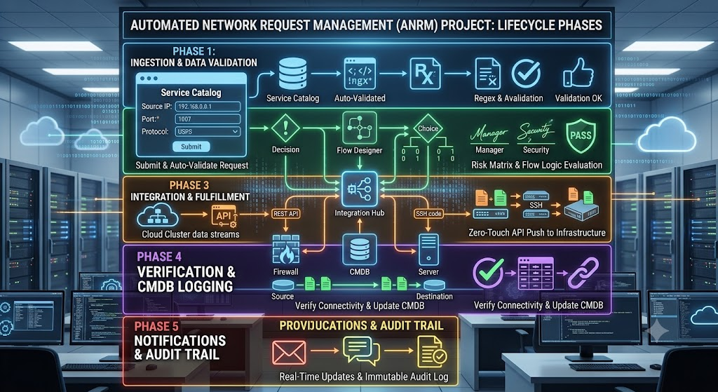

1. CUSTOMER SEGMENTS
- End-users (employees) who require network access, VPN setups, or firewall port configurations to do their jobs.
- IT Network Fulfillers who need clean, organized data to process requests efficiently.

2. JOBS-TO-BE-DONE / PROBLEMS
- Submit requests for network services without needing to understand complex IT jargon.
- Get rapid manager approval for restricted network access.
- Track the exact status of a submitted request in real-time.

3. TRIGGERS
- An employee is assigned to a new project and hits a network block or firewall restriction.
- A new hire is onboarding and needs standard VPN access.
- A deadline is approaching, making the lack of connectivity an urgent roadblock.

4. EMOTIONS BEFORE / AFTER
- Before: Frustrated, blocked, and anxious about missing project deadlines due to slow IT processes.
- After: Relieved, empowered, productive, and confident in the IT team's support capabilities.

5. AVAILABLE SOLUTIONS
- Sending manual, unstructured emails to the IT Helpdesk.
- Walking physically to the IT department to ask for access.
- Using outdated, cluttered legacy ticketing systems that ask irrelevant questions.

6. CUSTOMER CONSTRAINTS
- Technical Knowledge: Users often do not know their device's MAC address or specific network node requirements.
- Time: Users do not have the time to chase down managers for manual email approvals.

7. BEHAVIOUR
- Users submit incomplete tickets because they do not understand the forms.
- Users frequently ping IT staff on chat to ask, "What is the status of my request?"
- Users complain to their department heads about IT being a bottleneck.

8. CHANNELS of BEHAVIOUR
- Online: Microsoft Teams, Slack, Outlook/Email, company intranet portals.
- Offline: Face-to-face desk visits, physical IT service desks, phone calls to the helpdesk.

9. PROBLEM ROOT CAUSE
- Lack of automated workflow routing; requests sit in inboxes waiting for manual manager approval.
- Forms are static and not dynamic, leading to user confusion and poor data quality.
- Zero visibility or automated communication regarding request status.

10. YOUR SOLUTION
- A user-friendly, self-service portal in ServiceNow featuring a dynamic Network Request catalog item.
- Automated multi-tier approval workflows that instantly route to the correct manager.
- Real-time email notification triggers (at submission and completion) to eliminate status-chasing.

